**Schedule**

**Week of 04/11**

* Create a homepage on your laptop
  + An HTML/CSS/JS Home page  that displays the company name/info/logo/etc
  + The page should have a link to the login page
* Create a login page on your laptop
  + Page uses a form to input a user name and password
  + To test, the js code should include several valid userid/passwords
  + At this stage, it should just display a valid login message
* Create two MySQL tables on your laptop
  + A users table with columns
    - userid, password, user name, email, zipcode,
    - type=Customer, Employee, Admin
    - Any other fields you deem required
  + An investment table with columns
    - Userid
    - Balance in 4 currencies

**Week of 04/18 - Although no class**

* Port all of the above on to your AWS server
* Create a DISPLAY INVESTMENTS page for a customer
  + To test, have js code with a valid userid and their investments

**Week of 04/30**

* Update the login page to connect to the MYSQL database and use data from table
* Use session variables so home page can
  + display  login status
  + validate the link the to the display investments
* Port to AWS
* Update the display investments page to use actual data from the table
* Port to AWS

**The Home and Login/Out Pages**

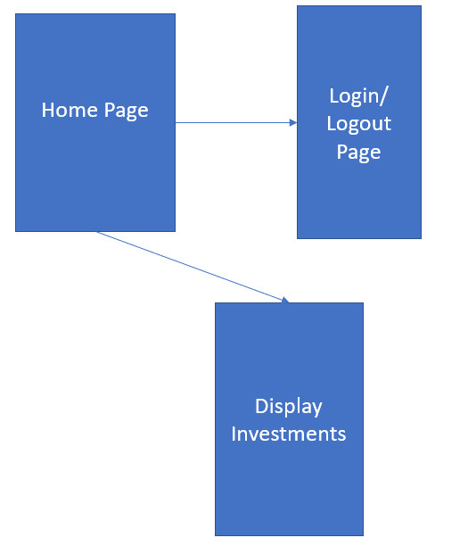

The Display Investments page should only be displayed if the user is LOGGED IN.

The Login Page Full Operation

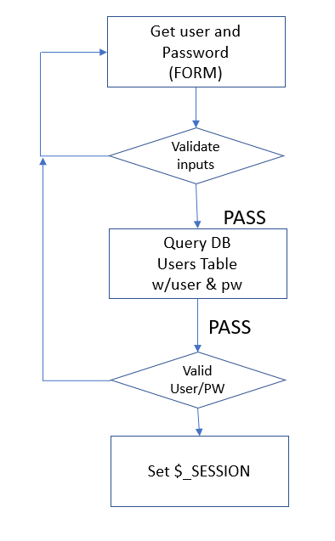

The login page is going to get input form the user (userid and password).

It should check the input to make sure that they are valid – alphanumeric, no”odd’ characters, a specified length, etc. If the inputs are ‘bad’ we redisplay the form with an error message.

If he inputs are good, we do a MYSQL search to see if the user/password combination is a match. If it is NOT a match, we redisplay the form with an error message.

If the user/pw is a match, we display a SUCCESSFUL LOGGED IN message.

We also set a SESSION variable with the status

Our main page will display the login status and also use it to determine which pages the user has access to.

**The Display Investments Page**

If the current user is a customer, this page should only display that user’s investments.

If the current user is an employee, this page should display every user’s investments.